Exercise 1

The task for exercise 1 was to analyse the frequency of letters in an English text and compare that to the frequency of letters in a ciphertext and record the difference. From this analysis we were to decrypt the ciphertext. Doing a cyptanalysis of the ciphertext actually turned out to be relatively simple, all things considered. Admittedly, I started working under the assumption that we were decrypting a substitution cipher (where all letters were switched independently of one another), as opposed to a shift cipher (where all letters were simply shifted a certain amount in a direction), which might explain why some of my methods are a little off. I was able to adapt what I had worked on into a successful shift cipher decryption program. The program starts off by performing a frequency analysis on both files input into the function “decrypt.”

The way in which my frequency analysis works is that the file is read into a String, which is then passed through a function to remove all non-alphabetic characters and change all alphabetic characters to lower case. This String is then converted into a character array. The character array is passed into the function “group” which counts the characters and assigns them in to a HashMap, where the letter is the key and the count is the value (Figure 1).
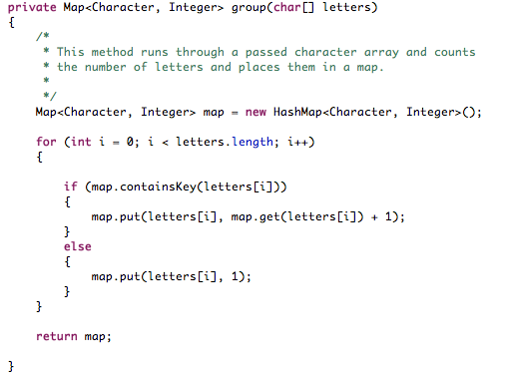Figure 1: The "group" method.
The grouped Map is then given to the “getFreq” method, which adds up the values of all of the letters to obtain the total number of characters in the text, then derives the frequency of each letter by dividing the count of the character by the total number of letters in the text. This is stored into another HashMap with the character as the key and a double as the value. The map from this function is given to a sort method which inverts the key and the value (so the Key is the frequency and the Value is the character) and places them in a TreeMap. This allows for the sorting of characters by the frequency which they appear in the text (because of how the TreeMap works, the least used characters will be first in the Map and the most used the last).

At this point we have two TreeMaps in our program. One with the sorted frequency analysis of the base text and one with the same from the ciphertext. The values from these two maps are removed in reverse order and put as the key and value of a new HashMap (with the most frequent character in the base text placed as the key against the most frequent character in the ciphertext as the value, and moving up the map like that (Figure 2.). Using the commonly known results from frequency analysis of English texts, and the results we obtained from analysing the base text given to us (Arthur Conan-Doyle's Sherlock Holmes, a text which produced little/no difference between the expected results and the actual results) we know that the most frequent letter in the English language is 'e' and from this can assume that the letter in our “swapper” map that is matched with 'e' from our frequency analysed ciphertext is the most frequent letter in that text. This letter is 'i'. Thus, by subtracting the letter 'e' from this we obtain the shift value for our ciphertext (a value of 4, or -22). A point to mention here: this will only work if the ciphertext is long enough to be analysed effectively; a shift cipher operating on a file which contains less than about 30 characters might not be able to be analysed this efficiently.

The final part of this program is the “done” function which, as it says in the name, finishes the decryption by shifting all alphabetic values in the cipher text by the shift value. This is done in a way that leaves punctuation in place, yet capitalisation isn't. Expanding the “if” function to incorporate capitals would be relatively simple, though. The program finishes by printing off the decrypted text (Figure 3.) into the console; this is only a test function though, and the result could easily be piped into a text file if the user wanted to.

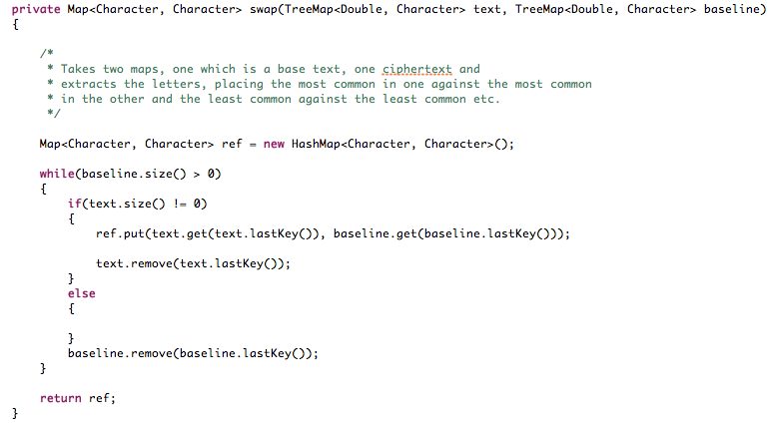Figure 2: The "swap" function.
Figure 3: The start of the deciphered text.
Due to the way in which I have constructed this program, I believe it would be relatively simple to alter the program, and it would only require a slight alteration, to enable it to decipher a substitution cipher, which also uses frequency analysis. This would require some sort of manual tuning, but it would be easy enough to implement.

